### Semester Two Examination, 2017

### Question/Answer booklet

# MATHEMATICS

**METHODS**

**UNITS 1 AND 2**

## Section Two:

## Calculator-assumed

Name

Teacher’s name

## Time allowed for this section

Reading time before commencing work: ten minutes

Working time: one hundred minutes

## Materials required/recommended for this section

***To be provided by the supervisor***

This Question/Answer booklet

Formula sheet (retained from Section One)

***To be provided by the candidate***

Standard items: pens (blue/black preferred), pencils (including coloured), sharpener, correction fluid/tape, eraser, ruler, highlighters

Special items: drawing instruments, templates, notes on two unfolded sheets of A4 paper, and up to three calculators approved for use in this examination

## Important note to candidates

No other items may be taken into the examination room. It is **your** responsibility to ensure that you do not have any unauthorised material. If you have any unauthorised material with you, hand it to the supervisor **before** reading any further.

## Structure of this paper

|  |  |  |  |  |  |
| --- | --- | --- | --- | --- | --- |
| Section | Number of questions available | Number of questions to be answered | Working  time (minutes) | Marks available | Percentage of examination |
| Section One:  Calculator-free | 8 | 8 | 50 | 52 | 35 |
| Section Two:  Calculator-assumed | 13 | 13 | 100 | 98 | 65 |
|  | | |  | **Total** | 100 |

|  |  |  |
| --- | --- | --- |
| Markers use only | | |
| Question | Maximum | Mark |
| 9 | 6 |  |
| 10 | 8 |  |
| 11 | 6 |  |
| 12 | 7 |  |
| 13 | 6 |  |
| 14 | 8 |  |
| 15 | 6 |  |
| 16 | 8 |  |
| 17 | 8 |  |
| 18 | 11 |  |
| 19 | 8 |  |
| 20 | 8 |  |
| 21 | 8 |  |
| S2 Total | 98 |  |
| S2 Wt (×0.6633) | 65% |  |

## Instructions to candidates

1. The rules for the conduct of examinations are detailed in the school handbook. Sitting this examination implies that you agree to abide by these rules.

2. Write your answers in this Question/Answer booklet.

3. You must be careful to confine your response to the specific question asked and to follow any instructions that are specified to a particular question.

4. Additional working space pages at the end of this Question/Answer booklet are for planning or continuing an answer. If you use these pages, indicate at the original answer, the page number it is planned/continued on and write the question number being planned/continued on the additional working space page.

5. Show all your working clearly. Your working should be in sufficient detail to allow your answers to be checked readily and for marks to be awarded for reasoning. Incorrect answers given without supporting reasoning cannot be allocated any marks. For any question or part question worth more than two marks, valid working or justification is required to receive full marks. If you repeat any question, ensure that you cancel the answer you do not wish to have marked.

6. It is recommended that you do not use pencil, except in diagrams.

7. The Formula sheet is not to be handed in with your Question/Answer booklet.

Section Two: Calculator-assumed 65% (98 Marks)

This section has**thirteen (****13)** questions. Answer **all** questions. Write your answers in the spaces provided.

Working time: 100 minutes.

Question 9 (6 marks)

(a) The tangent to the curve $y=16+2x-{2x}^{2}$ at $(2, 12)$ intersects the $x$-axis at $(a, 0)$. Determine the value of $a$. (3 marks)

(b) If $f^{'}\left(x\right)=3x-x^{3}-1$ and $f\left(3\right)=0$, determine $f(1)$. (3 marks)

Question 10 (8 marks)

A group of 160 students were asked whether they had bought a drink or a snack from the school canteen. 32 had bought neither, 32 had bought both and 112 had bought a drink.

(a) Determine the number of students who only bought a snack. (2 marks)

(b) Determine the probability that a randomly chosen student from the group had bought

(i) a drink or a snack. (1 mark)

(ii) only a drink. (1 mark)

(iii) a drink given that they had bought a snack. (2 marks)

(c) For this group of students, are the events buying a snack and buying a drink independent? Justify your answer. (2 marks)

Question 11 (6 marks)

Line $L_{1}$ has equation $5x-2y=20$.

(a) Sketch the graph of $L_{1}$. (2 marks)

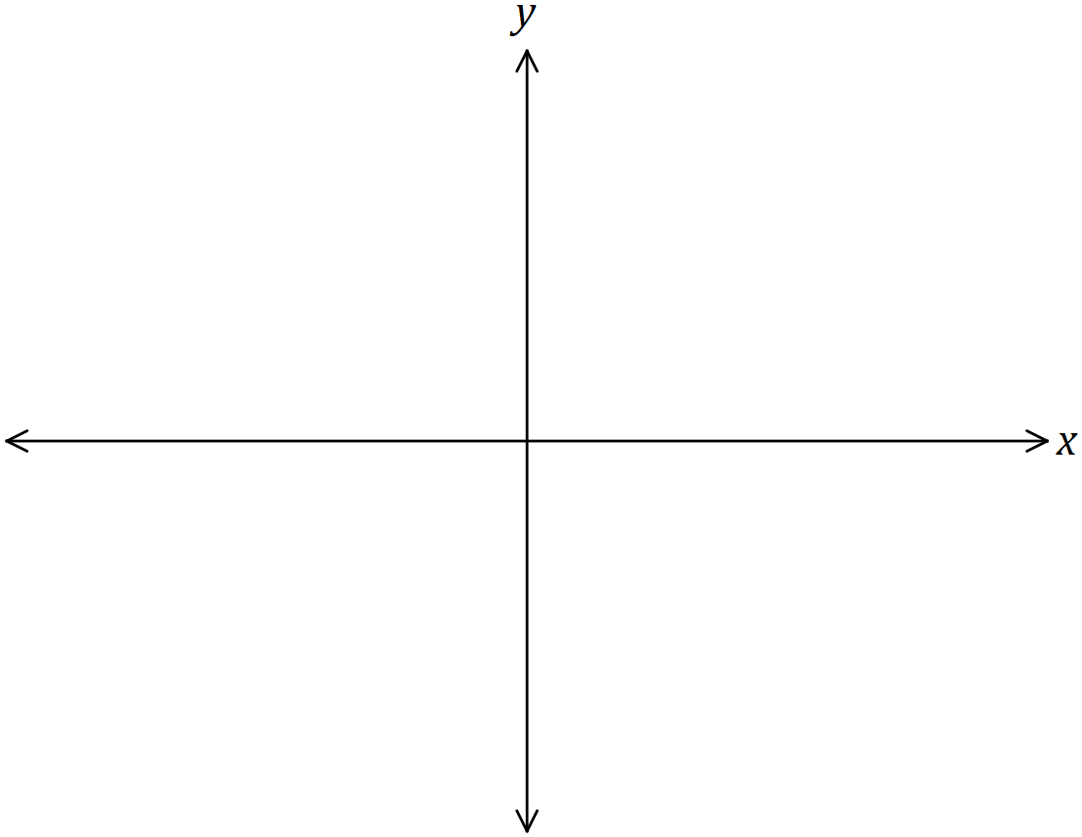

(b) Determine the equation of line $L_{2}$ that is parallel to $L_{1}$ and passes through the point with coordinates $(-3, -11)$. (2 marks)

(c) Determine the equation of line $L_{3}$ that is perpendicular to $L_{1}$ and has the same $y$-intercept as $L_{1}$. (2 marks)

Question 12 (7 marks)

(a) The graphs of $y=a\cos{x}$, $y=sin⁡(bx)$ and $y=\tan{(x+c)}$ are shown below.

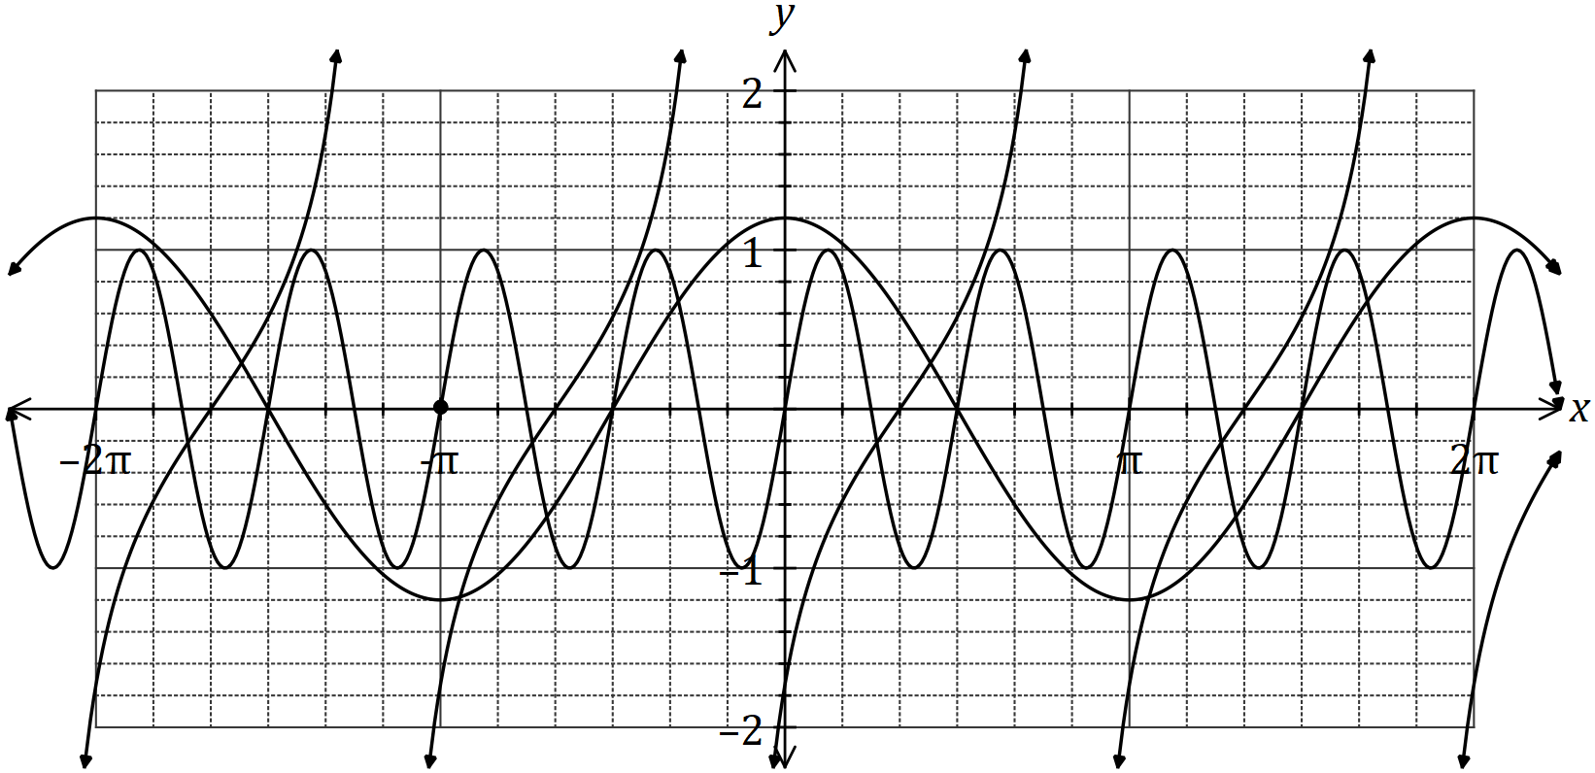

Determine the values of the constants $a$ and $b$ and the smallest positive value of the constant $c$. (3 marks)

(b) One day, the depth of water in a tidal basin was modelled by $d=5.5+3.7\sin{(0.5t-0.6)}$, where $d$ was the depth in metres and $t$ was the time, in hours, after midnight. For this day, determine

(i) the depth of water at 9.30 am. (2 marks)

(ii) the last time in the afternoon that the depth of water was 8.3 m. (2 marks)

Question 13 (6 marks)

The quadratic function $f\left(x\right)=ax^{2}+bx+c$ passes through $P(5, 9)$ and has roots at $x=-4$ and $x=7$.

(a) Determine the values of the constants $a$, $b$ and $c$. (3 marks)

(b) State the location of the $y$-intercept of the graph $y=-3f(x)$. (1 mark)

(c) State the location of the roots of the graph $y=f(4x)$. (2 marks)

Question 14 (8 marks)

**(a)** Evaluate the following and leave your solution in standard form (scientific notation).

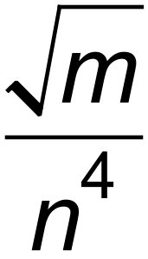 if 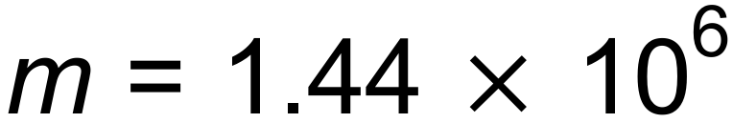 and 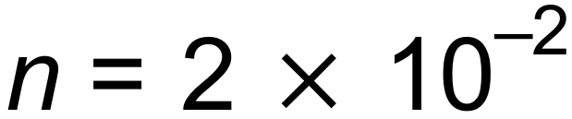 (3 marks)

**(b)** The number of bacteria, *P*, in a culture increases with time, in hours, according to the equation *P* =  *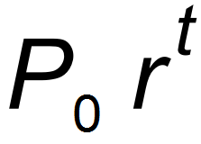.* The initial number of bacteria in the culture was 1200 and six hours later there were 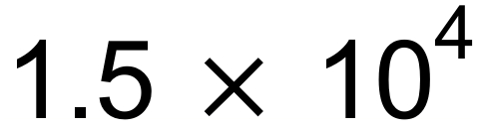 bacteria.

**(i)** Determine the values of *P0* and *r.* (2 marks)

**(ii)** How many bacteria would there be after 12 hours? (1 mark)

**(iii)**

Determine, to the nearest minute, when the number of bacteria will reach 1 000 000.

(2 marks)

Question 15 (6 marks)

(a) The variables $x$ and $y$ are related by ${\left(x+4\right)}^{2}+{\left(y-3\right)}^{2}=25$.

(i) Sketch the graph of this relationship. (3 marks)

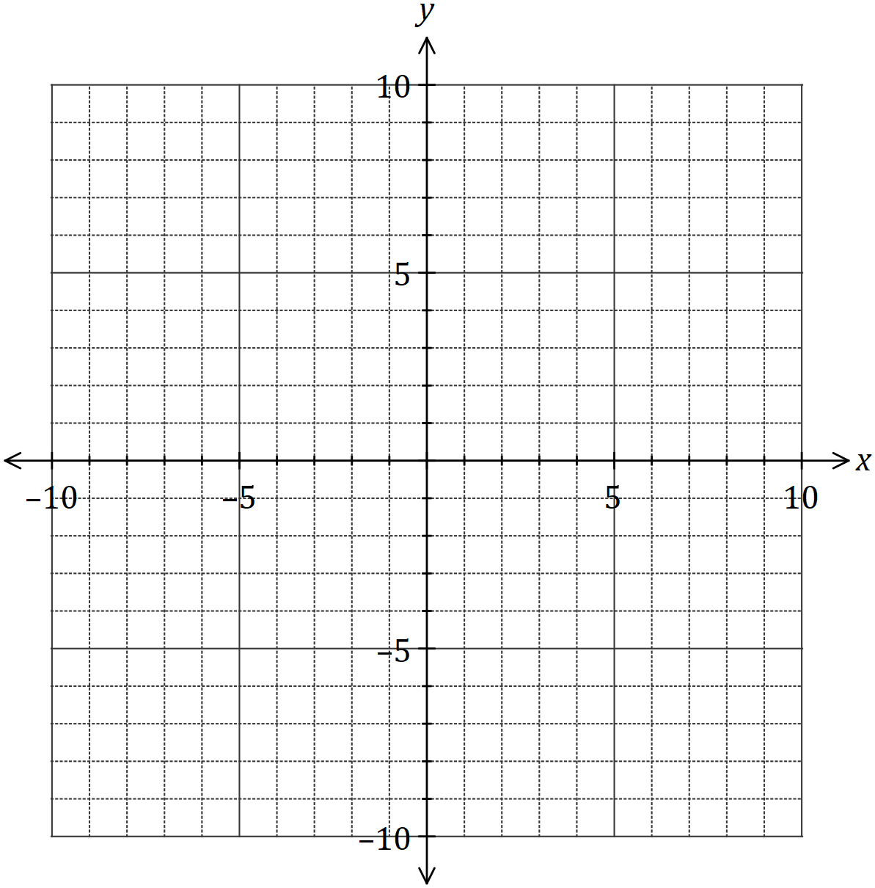

(ii) How does the vertical line test indicate that $y$ is not a function of $x$? (1 mark)

(b) State the domain and range of the function $f\left(x\right)=4-\sqrt{x+3}$. (2 marks)

Question 16 (8 marks)

The graph of $y=a^{x}$ is shown below, where $a$ is a positive constant.

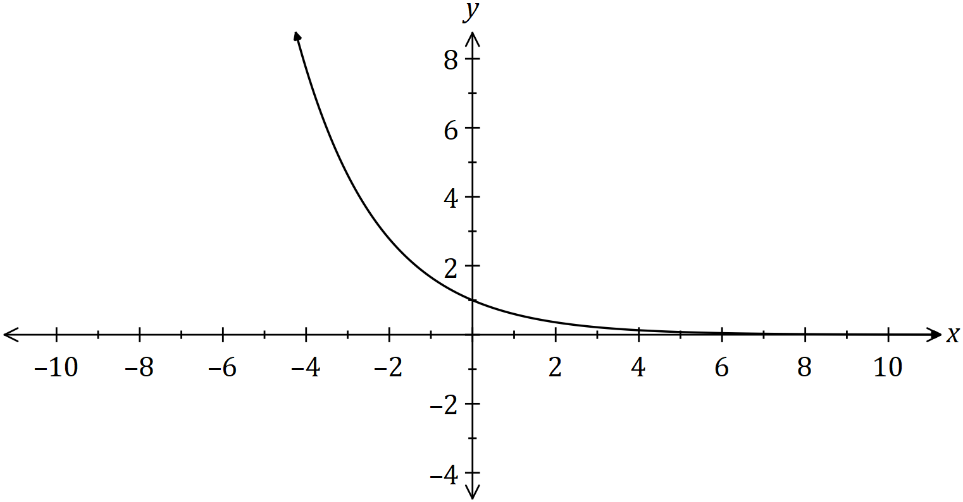

(a) On the same axes, sketch and label the graphs of

(i) $y=a^{x-3}$. (2 marks)

(ii) $y=a^{x}-2$. (2 marks)

(b) The graph of $y=a^{x-3}$ intersects the graph of $y={1.2}^{x}$ when $x=2.1.$

Determine, giving your answers to 3 significant figures,

(i) the $y$-coordinate of the point of intersection. (1 mark)

(ii) the value of the constant $a$. (3 marks)

Question 17 (8 marks)

A particle is moving along a straight line so that its displacement, $x$ metres, from a fixed point $O$ after $t$ seconds is given by

$$x=5-\frac{18t}{5}+\frac{12t^{2}}{5}-\frac{2t^{3}}{5} .$$

(a) Sketch the displacement of the particle on the axes below for $0≤t≤5$. (3 marks)

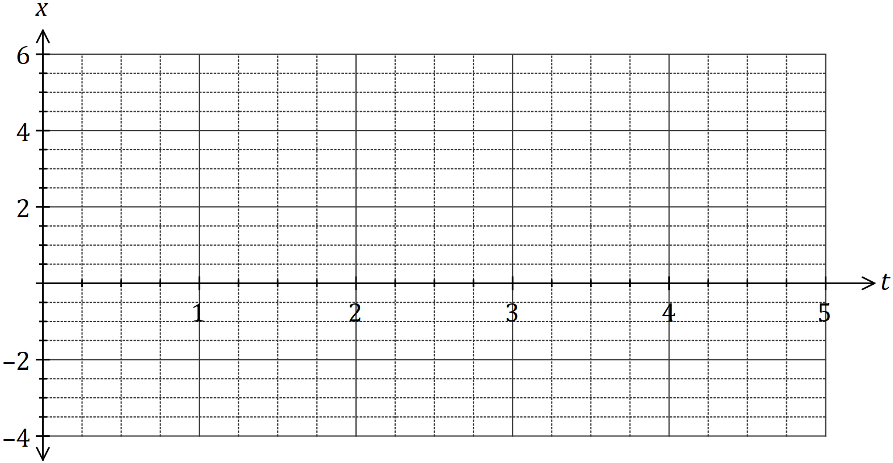

(b) Determine the velocity of the particle when $t=0.5$. (2 marks)

(c) For how long during the first five seconds is the particle is moving towards $O$? (1 mark)

(d) Circle the point on the graph where the particle is moving with the maximum velocity and explain what feature of the graph you used to choose this point. (2 marks)

Question 18 (11 marks)

Two circles of radii 10 cm and 13 cm have centres at $A$ and $B$ respectively. The centres are 7 cm apart and the circles intersect at $P$ and $Q$.

(a) Sketch a diagram of the two circles and clearly show triangle $ABP$. (2 marks)

(b) Show that $∠PBA=49.6°$, when rounded to one decimal place. (2 marks)

(c) Determine the length of the chord $PQ$ to the nearest millimetre. (2 marks)

(d) Determine the area common to both circles. (5 marks)

Question 19 (8 marks)

Events $A$ and $B$ occur at random and it is known that $P\left(A\right)=0.2$ and $P\left(A∪B\right)=0.68$.

(a) Determine $P(B)$ when

(i) $A$ and $B$ are mutually exclusive. (1 mark)

(ii) $P\left(A∩\overline{B}\right)=0.15$. (1 mark)

(iii) $A$ and $B$ are independent. (3 marks)

(b) Determine $P\left(A|B\right)$ if $P\left(A|\overline{B}\right)=0.36$. (3 marks)

Question 20 (8 marks)

Five different letters are selected from the eleven in the word COMRADESHIP. The order in which the letters are selected is not important, so that the selection COMRA is the same as the selection RAMOC, and so on.

(a) Determine the number of different selections

(i) of five letters. (2 marks)

(ii) of five letters that contain one vowel and four consonants. (2 marks)

(b) Determine the probability that a random selection of five different letters

(i) includes the letters M and R. (2 marks)

(ii) includes at least one vowel. (2 marks)

Question 21 (8 marks)

A composite solid is made from a cone and a cylinder, both of height $h$ cm and radius $r$ cm, as shown below.

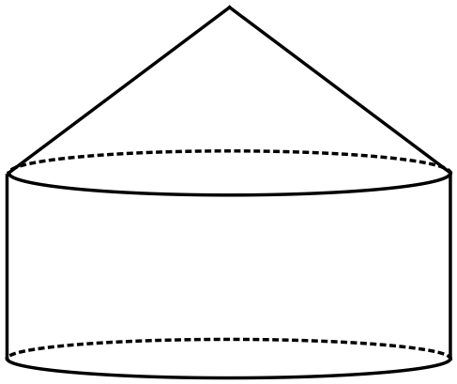

The dimensions are such that the sum of $h$ and $3r$ is $36$ cm.

(a) Show that the volume of the solid is given by $V=48πr^{2}-4πr^{3}$. (3 marks)

(b) Use differentiation to determine the values of $r$ and $h$ that will maximise the volume of the solid, and state this maximum volume. (5 marks)

Additional working space

Question number: _________

Additional working space

Question number: _________

Additional working space

Question number: _________